**ISAD251**

**Database Application**

**Development**

**20 CREDIT MODULE / 50% COURSEWORK SUBMISSION**

**/ 50% EXAM**

**MODULE LEADER: SHIRLEY ATKINSON**

**MODULE LECTURER: WILLIAM PANG**

**STUDENT:**

Name: WONG, WING HO

Student ID: 20042520

1. **Storyboard of Application**

* For Public & Customer

This is the landing page for all people.  
  
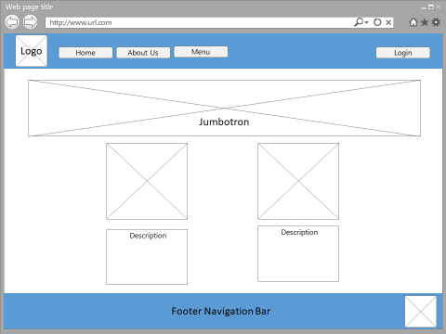

Public will see a “Sign-in” bottom at the “Menu”.  
  
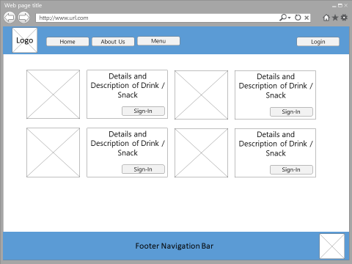

Public are required to sign-up for ordering items.

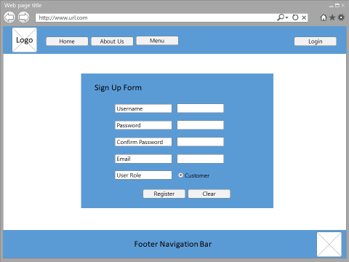

Customer are required to sign-in for ordering items.

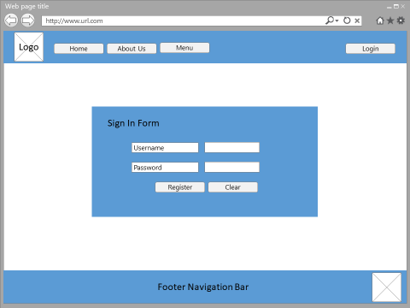

After sign-in, a button “Add to Cart” will be displayed in the Menu Page. Customer can check other added item in the “Shopping Cart” at the top of navigation bar. If customer is ready to checkout, just click “checkout”

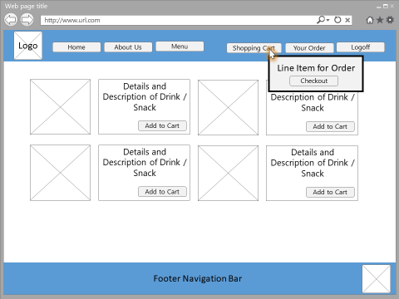

An order form will be displayed. Corresponding line item will be listed.

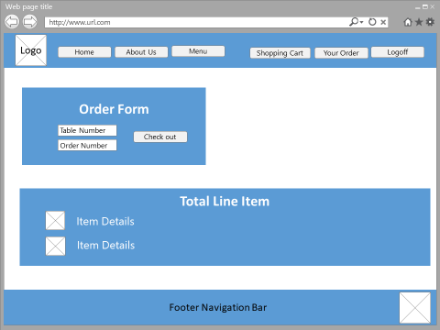

This is the page for customer who want to check their orders.

More details of ordered items can be checked by selecting “OrderDetails” button

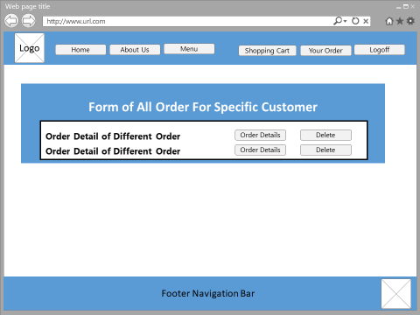

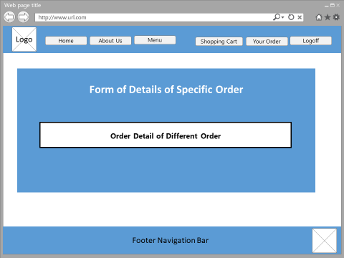

* For Administrator

Administrator is required to log-in.



Two different tab (Product Management & Order Management) will be shown after administrator is logged-in.

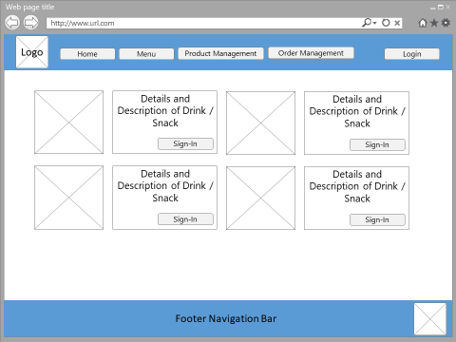

This is the page of product list. Administrator can view details of items, create new items, or edit specific item.

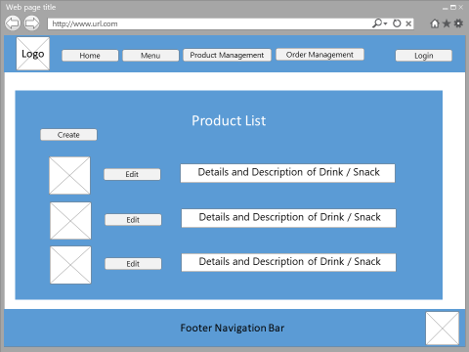

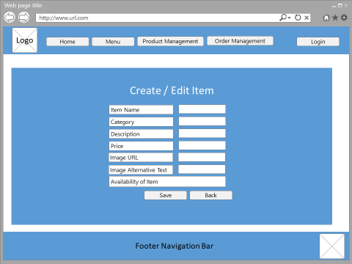

This is the page for administrator who want to check all customers’ orders.

More details of ordered items can be checked by selecting “OrderDetails” button

It also provide a searching function for administrator to search specific user’s order by name.

